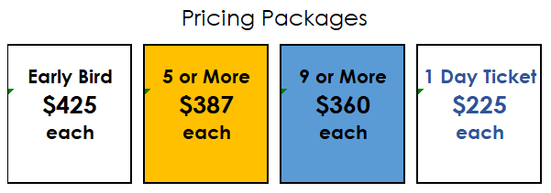
 | Two-Day Attendee List
 | Name of Attendee |  | Email of Attendee |  | Phone |  | Total
1
2
3
4
5
6
7
8
9
10
11
12
13
14
15
 | One-Day Attendee List
 | Name of Attendee |  | Email of Attendee |  | Phone |  | Total
1
2
3
4
5

Grand Total

Company Name

Who should we contact for payment?
Name |  |  |  |  |  |  |  |  |  |  |  |  | Phone
Email
We'd like to pay via
 | ACH |  |  |  | Credit Card |  |  |  | Invoice

Please send us your completed form and we will contact you for payment!
Email to: academy@universalss.com
Fax to: (810) 653-8515 Attn: LISA
Call: (810) 653-5000 x 334

